Lab 7 task 4: Configure the ESXi Hosts as NTP Clients

You configure the sa-esxi-01.vclass.local and sa-esxi-02.vclass.local ESXi hosts to use Network Time Protocol (NTP) so they can maintain the accurate time and date.

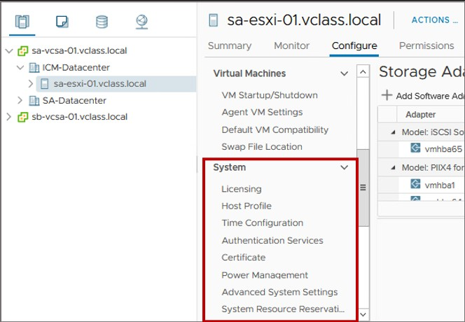

- In the navigation pane, select sa-esxi-01.vclass.local and click the Configure tab in the right pane.
- In the right pane under System, select Time Configuration.
- Next to Network Time Protocol, click EDIT. The Edit Network Time Protocol dialog box opens.
- Select the Enable check box.
- In the NTP Servers text box, enter 172.20.10.10.
- Next to NTP Service Status, select the Start NTP Service check box.
- From the NTP Service Startup Policy drop-down menu, select Start and stop with host.
- Click OK.
- In the Network Time Protocol pane, verify that the NTP client is Enabled and that the NTP service status is Running.
- Repeat steps 1 through 9 to configure sa-esxi-02.vclass.local as an NTP client.

